File No: IRF21/2497
Report to the Hunter and Central Coast Regional Planning Panel on an application for a site compatibility certificate under State Environmental Planning Policy (Housing for Seniors or People with a Disability) 2004 for 32 Industrial Drive, Mayfield
SITE: The site is located at 32 Industrial Drive, Mayfield North (Lot 100 DP 1084939) fronting Industrial Drive and William Street and has an area of 48,498m².
The site is used by the Wests Mayfield Club and includes a Balance Fitness Club, Gateway Inn Hotel, car park and is also home to the Newcastle Knights National Rugby League (NRL) team training facility and training ground. The training facility and ground is being relocated to Broadmeadow (currently under construction).
The primary car access to the site is from William Street near the intersection of Industrial Drive, providing access for customer and service drop-offs only. A service access is also available from the northern end of Antill Street at the southern boundary of the site. Pedestrian access will be provided throughout the site with access to the public domain at both Industrial Drive and William Street.
The site is surrounded by low-density residential areas to the east, south and west, including a small local park to the west (Avon Street Reserve). Mayfield town centre is 1km to the south. To the north, across Industrial Drive, are industrial lands related to the Port of Newcastle.
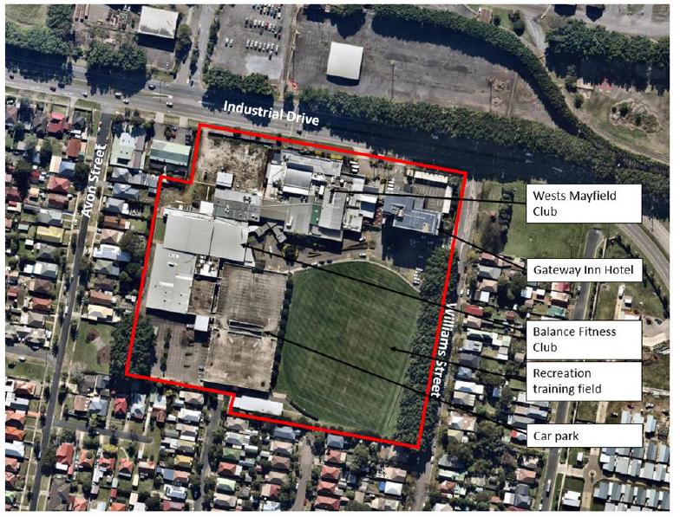Figure 1 Site map and on-site uses

APPLICANT: Western Suburbs (N'cle) Leagues Club Ltd
PROPOSAL: The application is for 176 self-care units in five separate buildings between 4 to 6 storeys in height, basement car parking for 302 cars and 16 motor bikes and community/ private open space.
The application will result in an additional 19,993m² of gross floor area (GFA), increasing the total site GFA to 31,863m², equivalent to a floor space ratio of 0.657:1.
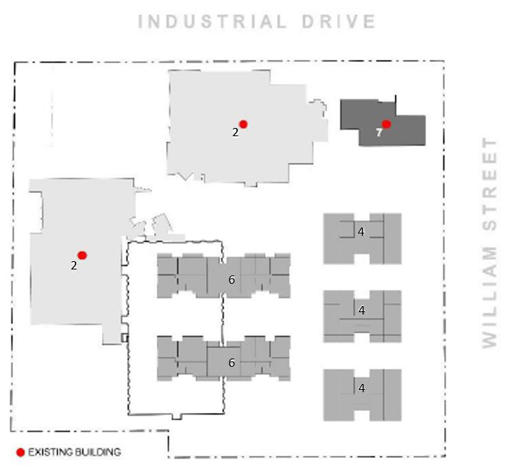Figure 2 Proposed building footprints and heights (storeys)
LGA: City of Newcastle
PERMISSIBILITY STATEMENT
The site is primarily zoned RE2 Private Recreation under Newcastle Local Environmental Plan 2012. A small portion on the southern boundary is zoned R2 Low Density Residential. The application is entirely on land zoned RE2 Private Recreation.
The site adjoins land zoned R2 Low Density Residential to the east, south and west. The proposed development is not permissible under the Newcastle Local Environmental Plan 2012.
The provisions under clause 4 of State Environmental Planning Policy (Housing for Seniors or People with a Disability) 2004 (Seniors Housing SEPP) provide that a site compatibility certificate can be issued because:
- the site adjoins land zoned primarily for urban purposes, which permits the development of dwelling houses;
- the site is being used for the purposes of a registered club, identified as Wests Mayfield Club (clause 4(1)(b)); and
- the land is not identified by any exclusions listed in Schedule 1 of the SEPP. Schedule 1 includes ‘open space’ however, as the land is used for a registered club and is described as private open space, clause 4(6)(a) states that the Seniors Housing SEPP remains applicable.
The type of seniors housing that may be developed on this land is identified in clause 17 of the Seniors Housing SEPP. The proposed development satisfies this requirement by providing self-care housing.
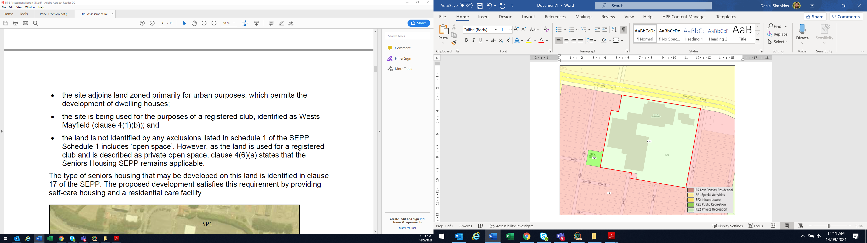 Figure 3 Land zoning map (site outlined red)
PREVIOUS SITE COMPATIBILITY CERTIFICATE REFUSED ON THE LAND
On 19 August 2019, a previous site compatibility certificate application for 262 serviced self-care dwellings and a 216 bed residential care facility was refused by the Hunter and Central Coast Regional Planning Panel (Panel).
The previous application sought to add an additional 38,390m² of GFA, increasing the total site GFA to 50,260m², equivalent to a floor space ratio of 1.036:1.
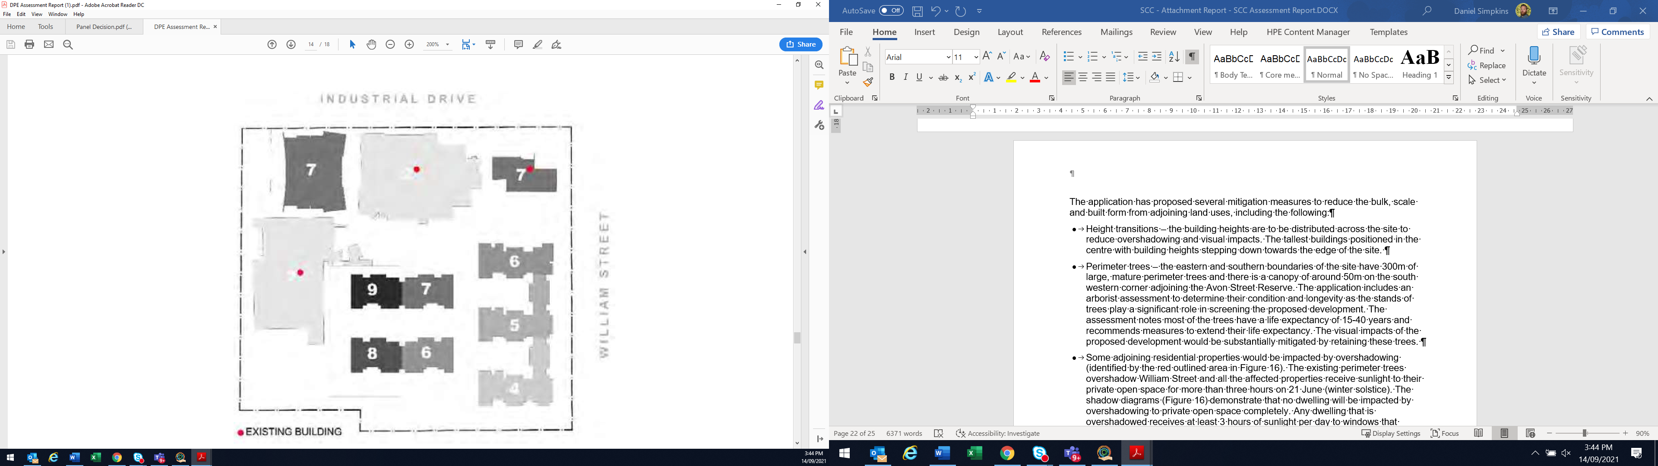 Figure 4 Previous site compatibility certificate application
In principle, the Panel considered the use of seniors housing as being suitable land use for the site given the nature of current uses and the nature of other existing residential and sensitive uses already present in the general locality.
The Panel decided it was unable to support issuing a site compatibility certificate for the development in the form proposed in the application. The Panel formed the opinion that significant change was required to site planning, building height and the density of the proposed development.
A summary outlining how the current proposal has responded to these matters raised by the Panel in the previous application is included in the table below. A more detailed table is included in Appendix I.
Panel’s position on previous proposal | How current proposal responds
Should demonstrate an aged care facility in the location proposed is able to provide reasonable amenity for future aged care residents, and an external appearance appropriate for a highly visible location, having regard to the treatments required to avoid impacts from adjoining port lands and also minimise impacts of the proposal on the future use of those port lands. | Residential aged care facility removed for the application.
Reduces building height, bulk and scale across the whole site, in particular adjacent to the William Street frontage, including increased setback from development to the Tree Protection Zone of the fig trees, breaking up the massing of development along this frontage and provides some visual permeability between building elements. Root mapping of the trees and an assessment of future growth potential may be required to inform site planning and setbacks. | The maximum dwelling yield has been reduced by 86 self-care units.  The amended design now proposes reduced:  - building height from 6-9 storeys down to 4-6 storeys; and  - 3 large buildings to 5 smaller scale, separated buildings.  Setbacks from William Street increased from 13m to 20m.  Setbacks from trunk of mature Ficus Hillii trees increased from 10m to 17m.  An Arborist has reviewed the trees and confirms no Tree Protection Zone encroachment for trees to be retained.
Provides sufficient information on contamination risk from groundwater and surface water originating from outside the site. | A groundwater contamination assessment report has been undertaken which demonstrates that the site is suitable for this form of development.
Provides sufficient information on the capacity for emergency access for residents during a PMF event and considers emergency egress through an access route not subject to potential future flooding. | The application includes a concept plan for emergency vehicle access to the site via Antill Street, clear of the PMF level.
Provides maximum dwelling yield that considers building height, bulk and scale that provides for good solar access to communal open space areas within the development site in mid-winter, where possible increasing the amount of communal open space for residents, and ensures satisfactory internal solar access to living rooms for future units and balconies. | The application has demonstrated that, with the new layout, solar access is maximised for winter solstice.
Provides building height, bulk and scale as well as landscape treatment that better responds to the low scale residential development surrounding the site. | The William Street interface includes three separate four storey buildings, breaking up the massing of the development and is screened by the mature fig trees.  The southern interface includes larger buildings setbacks a minimum of 18 metres from the boundary.  This interface already has the view of the multi storey carpark. New buildings over the carpark are further set back from this boundary.
Provides building height, bulk and scale that allows for some variation in building typologies across the site, other than variations in building height as proposed. | This has been achieved with the plans showing a reduced height and scale across the development footprint, increased permeability in the built form and an increased setback to the Tree Protection Zone of the Ficus Hillii trees.
PROXIMITY OF SITE TO WHICH THERE IS A CURRENT SITE COMPATIBILITY CERTIFICATE, OR AN APPLICATION HAS BEEN MADE BUT NOT YET DETERMINED
There is a site compatibility certificate within the City of Newcastle Local Government Area at 40 King Street, Adamstown, which is approximately 5.1km from the site.
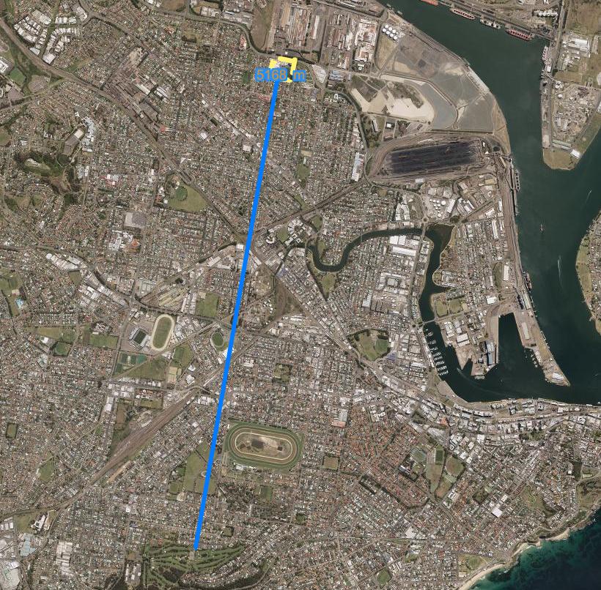
Figure 5 Nearby SCCs (source: NSW E-Planning spatial viewer)

CLAUSES 24(2) AND 25(5)
The Panel must not issue a site compatibility certificate unless the panel:
  - has taken into account any written comments concerning the consistency of the proposed development with the criteria referred to in clause 25(5)(b) received from the general manager of the council within 21 days after the application for the certificate was made;
  - is of the opinion that:
    - the site of the proposed development is suitable for more intensive development; and
    - the proposed development for the purposes of seniors housing is compatible with the surrounding environment and surrounding land uses having regard to the criteria specified in clause 25(5)(b).
CLAUSE 25(2)(C)
A cumulative impact study has not been prepared as there are no site compatibility certificates or undetermined applications within a 1km radius of the site.
COUNCIL COMMENTS
On 4 August 2021, City of Newcastle Council provided comments on the application (Appendix H).
Council did not object to development of the site for seniors housing. However, it raised the following concerns:
- the site is not in areas in the Newcastle Local Strategic Planning Statement or the Greater Newcastle Metropolitan Plan 2036 for future housing and employment growth.
- development of this site for intensive seniors housing may limit growth of the Greater Newcastle Metropolitan Plan’s Newcastle Port Catalyst Area. In addition, these areas may have amenity impacts (noise, light and odour) on senior residents within the development.
- height, scale and built form is inconsistent with the local strategy and the low-density residential development surrounding. The area is identified as a ‘limited growth precinct’ and the proposal is considered inconsistent with the low-density residential vision for Mayfield. Viewpoints and elevations provided are limited and do not offer sufficient detail to visualise the relationship with adjoining areas.
- the Newcastle Urban Design Review Panel should have been asked to comment on this application prior to lodgement.
- application will result in the loss of land for ‘recreation purposes.
- a site-specific flood assessment should support the site compatibility certificate. Particularly, as it includes a basement car park, and would be required to accompany a development application.
- contamination appears likely from the work undertaken to support the application and would require more detailed assessment to accompany the development application.
- more detail should be provided about staging, number of units, car parking and associated infrastructure.
- a no right turn requirement should be retained in William Street.
- car parking issues in relation to visitor parking in the existing carpark and whether sites are available and impacts on street parking.
Department response
The key issue for the application is the proposed scale, bulk and density of the development in relation to the surrounding residential neighbourhood and providing an appropriate transition to these areas. The built form is discussed further in this report.
Other issues such as car parking, management of local flooding, alignment with strategic planning documents, loss of land for recreation and proximity to industrial land are also discussed further in this report and do not pose any significant issues and can be addressed at the development application stage.
SUITABILITY FOR MORE INTENSIVE DEVELOPMENT
The panel must not issue a site compatibility certificate unless the Panel is of the opinion that the site of the proposed development is suitable for more intensive development (clause 24(2)(a)).
- The site of the proposed development is suitable for more intensive development (clause 24(2)(a))
In considering whether the site is suitable for more intensive development, the following matters have been considered:
Existing use
The site is zoned RE2 Private Recreation, reflecting the history of the site as a recreation area with services focused on employees from the industrial area.
The playing field that is proposed to be built on is a training facility for the Newcastle Knights NRL team and not accessible to the public. It is not confirmed if Wests Mayfield club members have access to the facility.
Gymnasium and indoor pool will remain accessible to club members and guests, the general public as well as future residents of the proposed development.
Public recreation of local parks, playgrounds and ovals are in walking distance.
Noise, amenity and access impacts from the club and hotel have been addressed in the design and include the following measures: separating the club, hotel and seniors buildings; the orientation of facilities; and providing separate entrances. The Department considers these measures appropriate, with the final design to be considered by the consent authority at the development application stage.
As the club contains gambling facilities, there will also be a need to implement appropriate harm minimisation measures (under clause 23 of the Seniors Housing SEPP) at the development application stage.
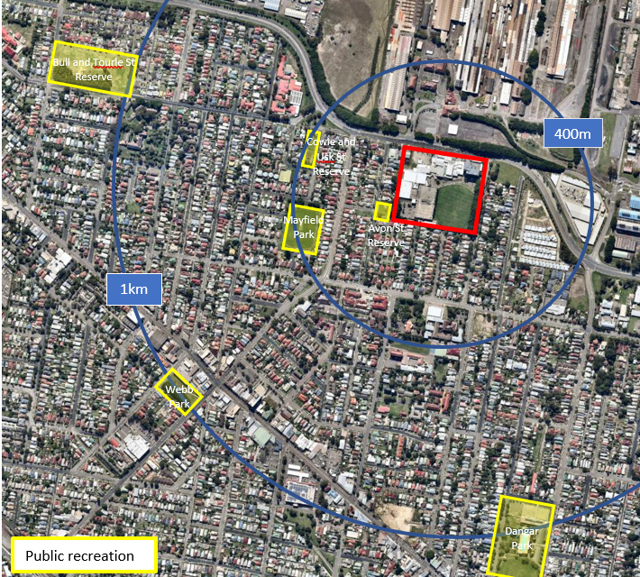
Figure 6 Nearby recreation facilities
Adjacent land uses
The areas to the east, south and west of the site are zoned R2 Low Density Residential. As part of the application, the scale and height of surrounding development was considered in designing the proposed development to manage the impact on these areas.
The proposed development will result in a development footprint on part of the site that is not developed and above the existing two storey carpark. The proposal is likely to have a visual impact on the adjoining residential areas and is not consistent with the local character and built form. These impacts are discussed later in this report.
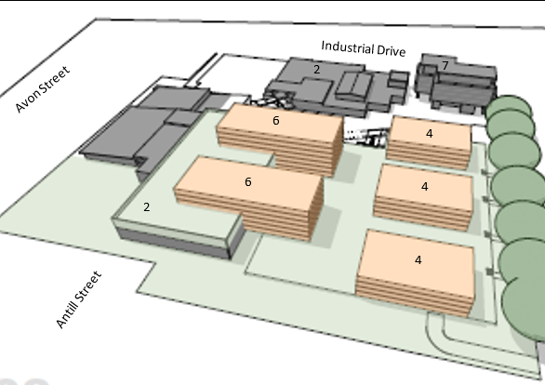
Figure 7 Building scale (storeys) and position on site
The 24-hour operations of the Newcastle Port on the opposite side of Industrial Drive influence the residential amenity of the area. The large-scale industrial buildings have historically provided an industrial character, built form and activity to this part of Mayfield. The potential impacts have been considered further in this report.
Access and public transport
Vehicular access to the site from Industrial Drive and William Street is the key infrastructure consideration, of which there are differing views. Industrial Drive is a state road corridor.
On 23 July 2018, the then Roads and Maritime Services (RMS) provided advice on the previous application that any proposal that results in additional impact on the intersection of Industrial Drive and William Street is unlikely to be supported. It advised the intersection of Industrial Drive and William Street currently experiences lengthy delays, particularly in the PM peak. To resolve this issue, the agency advised the intersection may need to be modified to remove the right only turn into William Street and direct traffic onto the local road network.
This proposal is in the current application. It relocated access directly from Industrial Drive into the south eastern corner of the site onto William Street. Flood-free emergency access is included along an internal road to Antill Street.
Council does not support the removal of the ‘no right turn’ from the site into William Street which would increase traffic in adjoining local neighbourhoods. The restriction arose from a previous approval for the club, gym and hotel development on the site to address residents’ concerns about increasing local traffic in the area.
The traffic impact assessment (Appendix F) concludes the proposal will not adversely impact on the local and state road networks and complies with all the relevant design standards. The assessment provides a car parking analysis for the existing and proposed development and concludes that surplus spaces will be available (302 spaces provided within basement carpark), even after part of the top floor of the existing multi-level car park is developed for residential uses.
The site has access to public transport, including a regular local bus service from Wallsend connecting directly with Newcastle and Mayfield centres and Waratah railway station. The Wests Mayfield Club also proposes to provide a dedicated community bus service for the senior residents.
The Department recommends that a requirement of the site compatibility certificate be that RMS’s requirements set out in Appendix E be addressed in any future development application.
Environmental constraints
The site is partly flood affected by the probable maximum flood in the north-eastern corner. A small part of the development is within the ‘flood fringe’ and can be addressed through building siting and design at the development application stage.
The probable maximum flood also affects access with the site. The application has addressed this issue by providing emergency access from the southern end of the site via Antill Street.
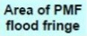
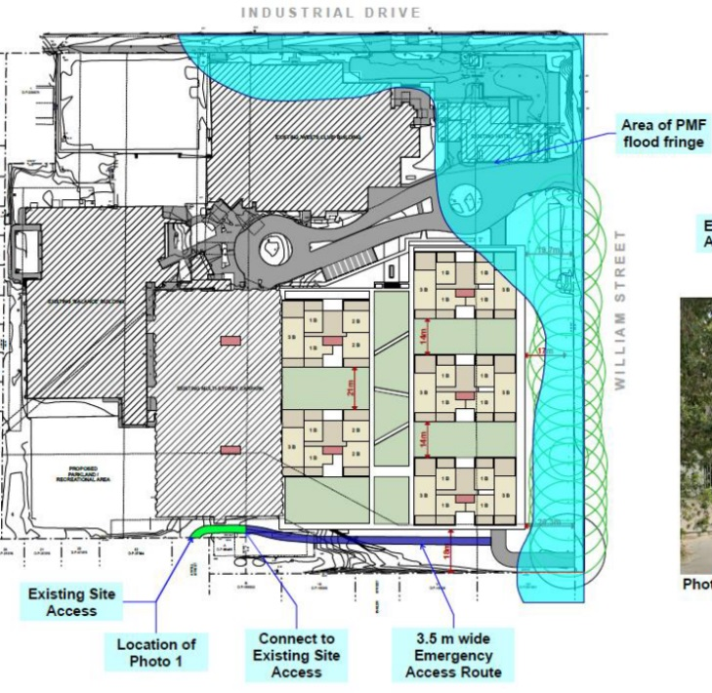Figure 8 Emergency access
ANTILL STREET
The site also contains class two acid sulfate soils, which can be managed at the development application stage. It is not bushfire prone.
Summary
The site is suitable for more intensive development as there are no significant constraints within the site for the following reasons:
- the use of the site for seniors housing would not adversely impact on future uses of this land;
- noise, amenity and access impacts from the club facilities have been adequately addressed;
- suitable access to the site has been identified and it is close to public transport services;
- environmental constraints, such as flooding and acid sulfate soils, can be managed at the development application stage; and
- adequate and suitable services are available in the area to support the proposal.
COMPATIBILITY WITH THE SURROUNDING ENVIRONMENT AND LAND USES
The Panel must not issue a site compatibility certificate unless the Panel is of the opinion that the proposed development for the purposes of seniors housing is compatible with the surrounding environment and surrounding land uses having regard to the following criteria (clause 25(5)(b)) and clause 24(2)(b)):
- The natural environment (including known significant environmental values, resources or hazards) and the existing and approved uses of land in the vicinity of the proposed development (clause 25(5)(b)(i))
To the north and north-east of the site is the state significant Newcastle Port land, including the wire-making mills. While the former BHP steelworks operations have mostly ceased, buildings and infrastructure still exist, and the area is proposed to be retained for port and industrial uses and is of state strategic importance.
Potential land-use conflict from existing and future port-related industrial uses is a key consideration for the application. The port operates 24 hours a day and potential impacts include noise, light spill, air quality, and heavy and dangerous goods vehicle movements.
Seniors housing is a sensitive receptor to industrial land uses. The proposed number of occupants may create implications for the ongoing operations of port-related activities, including noise complaints and an increased risk rating for Newcastle Port activities.
The development is located approximately 250m from industrial activities and is separated by a row of mature fig trees along the northern side of Industrial Drive, the road reserve and the existing club and hotel buildings. Future residents of the seniors housing are unlikely to be affected by noise or other impacts from the Mayfield North industrial area.
The site contains a row of mature fig trees along the William Street boundary. Two of these will be removed to provide separate access to the basement carpark.
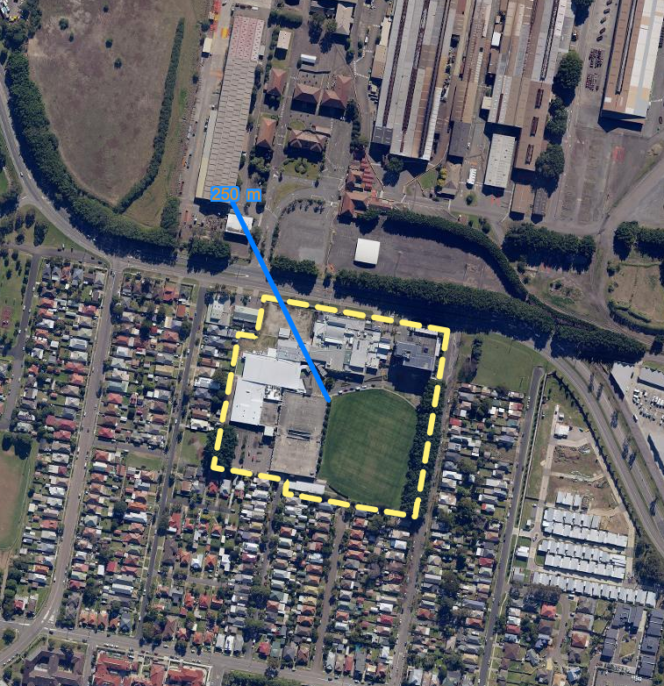Figure 9 Distance to industrial uses (source: NSW E-Planning spatial viewer)

- The impact that the proposed development is likely to have on the uses that, in the opinion of the panel, are likely to be the future uses of that land (clause 25(5)(b)(ii))
Private recreation
The site is zoned RE2 Private Recreation. One of the objectives of the zone is to provide private open space for recreational purposes.
The application will result in the loss of private recreation land. The loss of the football training ground will reduce the area used for recreational purposes as most of the site is proposed to be developed. The existing gymnasium and indoor pool are to be retained and be available to residents, Wests Club members, their guests and the public.
The football ground is used as a private training facility for the Newcastle Knights National Rugby League team and is not available for public use. As the training facility is being relocated to Broadmeadow, the development of this private recreation land is considered reasonable as the open space does not form part of council’s public open space network or serve a public function.
Hunter Regional Plan 2036
The Hunter Regional Plan 2036 provides regional policies and directions for land use focusing on the economy, environment, communities, housing and jobs. The following actions provide high level indications of the future use of the site.
Action 2.3 Prepare local plans that adequately respond to air, noise and other issues relevant to the gateways to protect their ongoing operations and expansion.
The seniors housing buildings are separated from port operations by the existing buildings in the northern part of the site and the mature trees on the northern side of Industrial Drive.
Traffic management issues can be resolved through a more detailed development assessment process with the involvement of Transport for NSW.
Action 21.4 Create a well-planned, functional and compact settlement pattern that responds to settlement planning principles and does not encroach on sensitive land uses, including land subject to hazards, on drinking water catchments or on areas with high environmental values.
The application includes flood-free emergency access through via an internal access road through to Antill Street. The site is otherwise relatively unconstrained by hazards and is unlikely to impact on drinking water catchments or areas with high environmental values.
Action 21.7 Promote new housing opportunities in urban areas to maximise the use of existing infrastructure.
The proposal is located approximately 4km from the Newcastle CDB and 750m from Mayfield local centre. It is well serviced by water, sewer, electricity and roads as well public transport, open space and local retail and medical services making it suitable for seniors housing.
The larger site area provides capacity for relatively higher density than the surrounding low-density areas, as the impacts of bulk, scale, overshadowing and privacy can be mitigated through increased setbacks and building configuration among other design considerations. These matters can be further assessed and resolved through a development assessment process.
Action 22.1 Respond to the demand for housing and services for weekend visitors, students, seasonal workers, the ageing community and resource industry personnel.
The application responds to the demand for housing for the ageing community as identified in City of Newcastle’s Local Housing Strategy.
Greater Newcastle Metropolitan Plan 2036
The application is consistent with the metropolitan plan, including the action to have 90 percent of houses within a 10-minute walk of open space. While the proposal will result in the loss of private open space, there is sufficient public open space near the site and the impact on available open space would be minimal.
Strategy 16 of the metropolitan plan seeks to prioritise the delivery of infill housing opportunities within urban areas. The application is consistent with this strategy and planning outcomes as it would provide infill development in an urban area that provides greater housing choice and diversity.
The Greater Newcastle Metropolitan Plan 2036 identifies the industrial area directly to the north of the site as the ‘Mayfield North Industrial Precinct’ and recognises the strategic importance of this area. The objectives are to:
- protect industrial land uses;
- investigate the potential diversification and growth of industrial land uses; and
- work with operators and industry to minimise impacts on residential communities.
The metropolitan plan states that land within the precinct will be retained for port and industrial uses. It also recognises the importance of Industrial Drive as a key freight route and the need to maintain the efficient movement of goods.
The nearby Mayfield Freight and Logistics Precinct aims to develop future freight and logistics, intermodal and warehousing to complement the export role of the port and continue to prohibit residential uses. These industrial areas should therefore be protected from encroachment of intensified residential land uses, which could limit the potential uses and continued operation of the industrial lands.
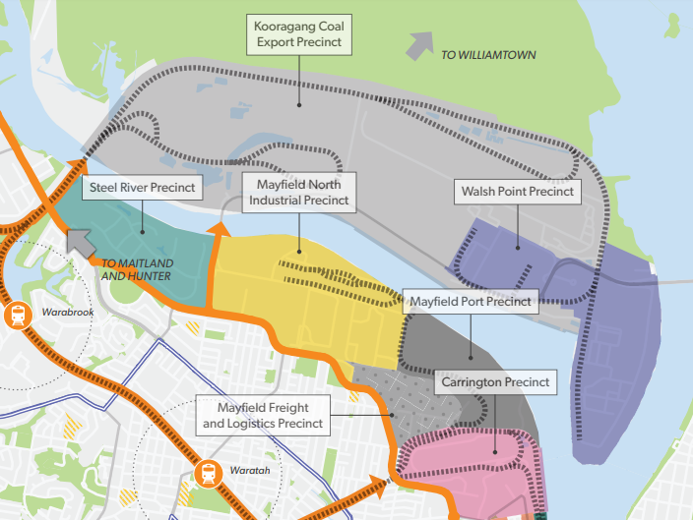Figure 10 Greater Newcastle Metropolitan Plan 2036 - Newcastle Port Catalyst Area
Subject site
Newcastle Local Strategic Planning Statement
The Newcastle Local Strategic Planning Statement (LSPS) guides council’s land use planning over the next 20 years. The LSPS includes planning priorities to achieve council’s land use planning vision.
LSPS Principle | Response
Prioritise active and public transport in the City, particularly in Catalyst Areas, Urban Renewal Corridors and Strategic Centres.  Encourage uptake of active transport by planning for short trips (distance of 400m to 4km). | The site has a bus stop in front of the Gateway Inn hotel on Industrial Drive, providing public transport links with local centres, Newcastle CBD and Waratah railway station.
The role of freight corridors is prioritised over the introduction of new residential and other sensitive land uses. | The application includes access to William Street at the south eastern corner of the site, thereby removing any access from Industrial Drive.  There are differing views between the relevant public authority and City of Newcastle Council regarding the direction of traffic exiting the site onto William Street.
Urban growth and change responds to environment and climate change risks and impacts.  Infrastructure and asset planning incorporates emergency management principles and disaster risk reduction. | Emergency flood access has been proposed above the probable maximum flood.
Housing at appropriate densities will be located to support effective and integrated public transport.  A culturally rich and vibrant community will be encouraged by providing a greater diversity of quality housing within each neighbourhood for current and future community needs. | The application will provide housing for seniors, which is an identified housing need for the City of Newcastle, on a site serviced by public transport.  The site is relatively large and has the capacity to accommodate a higher density than the low-density areas around its eastern, southern and western boundaries.  The application demonstrates a higher density outcome could reasonably be achieved on the site and will result in the provision of a housing type that meets current and future community needs.
The siting, design and configuration of the proposed development does not undermine the above aims. Further consideration will need to be given to any required changes to the road network and subsequent impacts on the operation of Industrial Drive for the purpose of efficient road freight movements.
- The services and infrastructure that are or will be available to meet the demands arising from the proposed development (particularly, retail, community, medical and transport services having regard to the location and access requirements set out in clause 26) and any proposed financial arrangements for infrastructure provision (clause 25(5)(b)(iii))
Location and access to facilities
The site is approximately 750m from local retail, community and medical services in Mayfield. The Mayfield town centre has supermarkets, speciality stores, public transport, and medical and community facilities.
The site is not within a 400m walk of facilities required by clause 26 of the Seniors Housing SEPP. The application includes a statement that Wests Mayfield Club will provide a dedicated community bus service in addition to the local public transport service. No details are provided in the application regarding frequency of the bus service. As such, details will of this service will need to be confirmed as part of any future development application.
The site is serviced by five bus stops within walking distance. The closest bus stop on Industrial Drive complies with gradient standards. Higher-order retail and services are available in the Newcastle CBD approximately 4km from the site, with frequent bus services operating during the day and evening, meeting the SEPP requirements.
Infrastructure
Electricity, water and sewer are available to the site. The proponent advised they are continuing to consult with service providers to determine if any upgrades are required to service the proposed development.
Council has expressed concerns that the application does not consider the existing usage of the multi-storey carpark and the loss of car parking spaces for club patrons. These issues can be resolved at the development application stage.
As the development is proposed by a private entity and not a social housing provider, the seniors living component would need to provide a total of 155 on-site car parks. The traffic impact assessment concludes 302 resident car parks are proposed within the concept plan with visitor parking to use the existing multi-storey carpark, therefore an excess of on-site car parking is provided for the development.
- In the case of applications in relation to land that is zoned open space or special uses—the impact that the proposed development is likely to have on the provision of land for open space and special uses in the vicinity of the development (clause 25(5)(b)(iv))
The site is zoned RE2 Private Recreation and the Newcastle Knights NRL club training facility will be relocated to Broadmeadow. As the training facility is not currently accessible to the public, there will be minimal impact on access to open space in the vicinity.
There is sufficient public open space near the site. Other recreation uses related to the club will continue to operate and be available to members, their guests, residents and the public. Land in the south western corner of the site adjoins Avon Street Reserve Playground. This area will be retained as communal open space.
- Without limiting any other criteria, the impact that the bulk, scale, built form and character of the proposed development is likely to have on the existing uses, approved uses and future uses of land in the vicinity of the development (clause 25(5)(b)(v))
The Newcastle Local Environmental Plan 2012 does not apply building height or floor space ratio controls to the site. The adjoining residential area generally consists of low-density residential sites and has a maximum building height of 8.5m.
The application comprises the following:
- two six storey independent living unit buildings in the centre of the site and on top of the car park;
- three four storey buildings fronting and setback from William Street;
- basement car parking for residents and existing above-ground parking for visitors; and
- community and private open space.
The proposed building heights are lower than the existing seven storey hotel, are setback behind the club, hotel and facilities and will also be setback from adjoining streets and land uses.
The four storey buildings sleeve the taller buildings to provide a transition down to the lower density dwellings. The proposed building buildings are also separated beyond the requirements of the Apartment Design Guide to break up the massing and bulk of the development.
To further reduce the visual bulk and scale of the buildings, setbacks are incorporated as follows:
- between 17m to 20.3m from the eastern boundary on William Street; and
- 18m from the southern boundary adjoining residential properties that front William and Hinkler Street.
Some adjoining residential properties would be impacted by overshadowing. The existing perimeter trees overshadow William Street and all the affected properties receive sunlight to their private open space for more than three hours on 21 June (winter solstice). The shadow diagrams demonstrate no dwelling will be impacted by overshadowing to private open space completely. Any dwelling that is overshadowed receives at least 3 hours of sunlight per day to windows that currently receive sunlight.
It would be appropriate to further consider minimising the impact of overshadowing on adjoining properties and solar access during detailed building design as part of a development application.
Mature fig trees along the eastern boundary and younger fig trees along the southern boundary provides screening. However, this should not be solely relied upon to mask the bulk and scale of the development.
Figure 11 3D Model demonstrating bulk, scale and setbacks
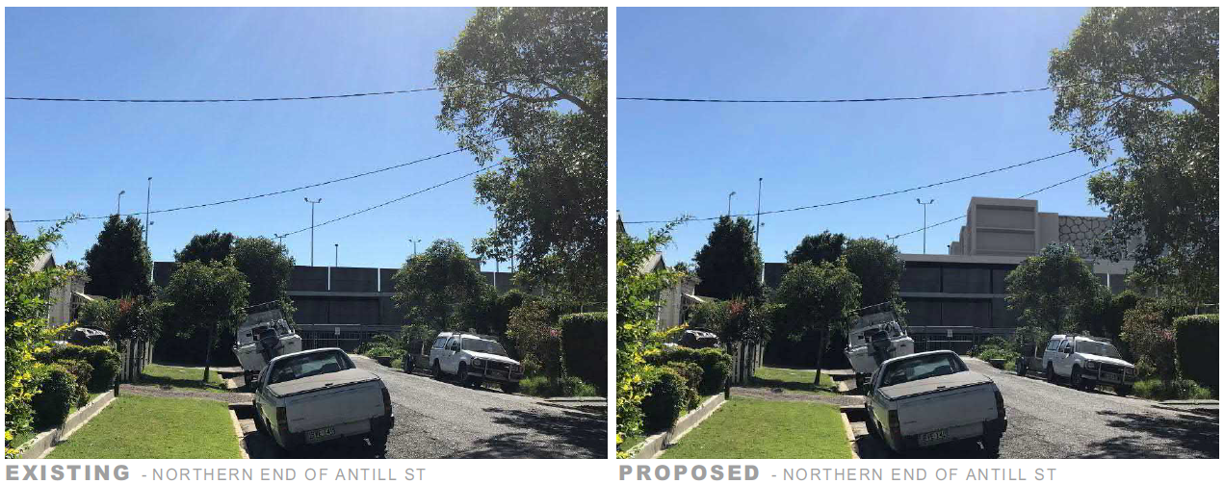Figure 12 View north from Antill Street towards proposed development
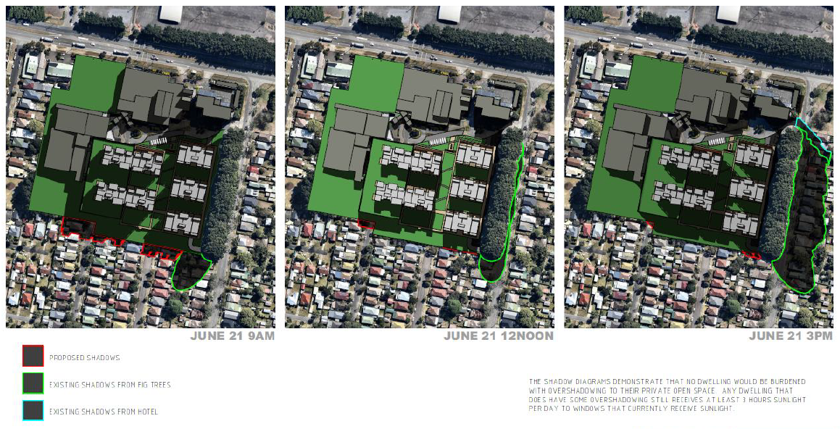Figure 13 Shadow diagrams
The application has proposed several mitigation measures to reduce the bulk, scale and built form from adjoining land uses, including the following:
- height transitions –building heights are distributed across the site to reduce overshadowing and visual impacts. The tallest buildings positioned in the centre with building heights stepping down towards the edge of the site.
- perimeter trees – the eastern and southern boundaries of the site have 300m of large, mature perimeter trees and there is a canopy of around 50m on the south western corner adjoining the Avon Street Reserve. The application includes an arborist assessment to determine their condition and longevity as the stands of trees play a significant role in screening the proposed development. The assessment notes most of the trees have a life expectancy of 15-40 years and recommends measures to extend their life expectancy. The visual impacts of the proposed development would be substantially mitigated by retaining these trees.
- the proposed concept plans show building separations in all instances exceeding the requirements of the Apartment Design Guide with some being almost double the required separation. Furthermore, the common open space area running north-south between the buildings will receive almost 4hrs of mid-winter sunlight.
- If the development may involve the clearing of native vegetation that is subject to the requirements of section 12 of the Native Vegetation Act 2003—the impact that the proposed development is likely to have on the conservation and management of native vegetation (clause 25(5)(b)(vi))
The proposed development will not involve the clearing of any remnant native vegetation. The application seeks to retain all but two of the mature Ficus Hillii trees. To allow access to the proposed basement carpark, two of these trees may need to be removed as the proposed works will render them not viable (see Arborist Report Appendix G).
- The impacts identified in any cumulative impact study provided in connection with the application for the certificate (clause 25(5)(b)(vii))
As there are no issued site compatibility certificates or undetermined applications within a 1km radius of the site, a cumulative impact study is not required.

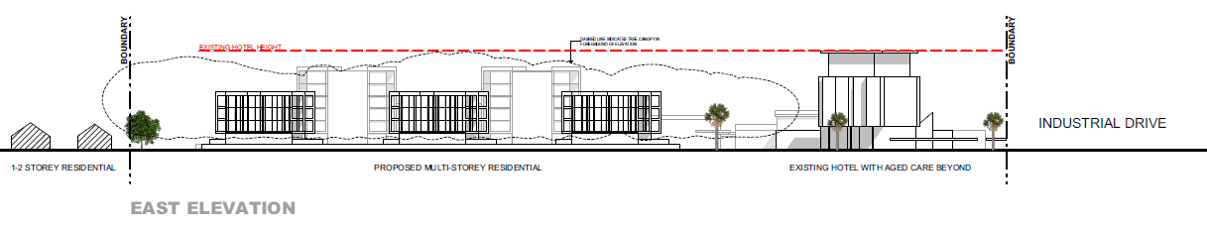Figure 14 Eastern elevation of current application
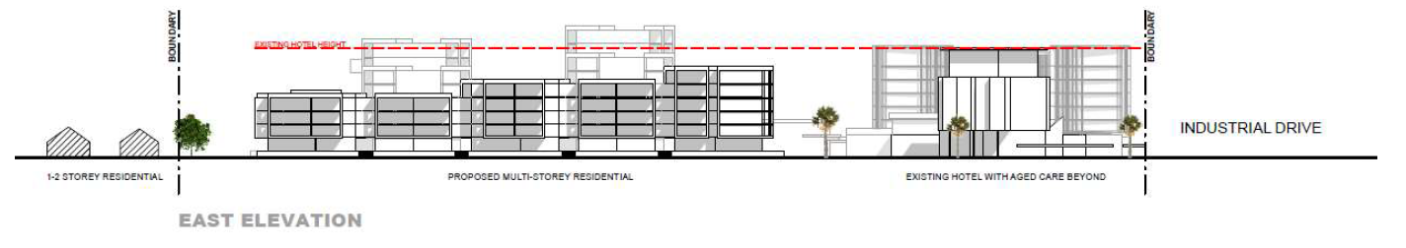Figure 15 Eastern elevation of previous application
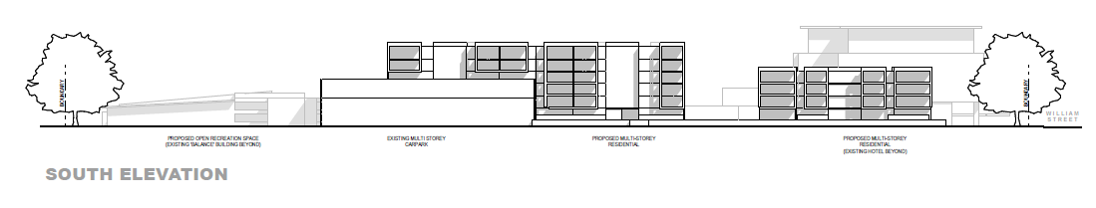Figure 16 Southern elevation of current application

CONCLUSION
The site is suitable for more intensive uses. The compatibility of self-care residential uses with industrial activities at the Port of Newcastle and 24-hour operations was a key consideration. The Department considers the potential impacts can be appropriately managed through design changes to the proposed development at the development application stage.
Adequate and suitable services are available, including access to public transport and the provision of a community bus.
The proposed requirements to be imposed on the site compatibility certificate are that any development application addresses:
- frequency and destinations of the proposed community bus service;
- overshadowing, solar access and visual impacts;
- impact of the loss of two fig trees to provide access and the on-going management and replacement of the mature fig trees over time;
- local flooding and design responses;
- potential contamination of the site and amelioration;
- visual analysis from Hinkler and William Streets and impacts of proposed tree removals; and
- the then RMS traffic and access requirements in consultation with City of Newcastle Council including measures to manage any increased local traffic impacts.
APPENDICES
Appendix A – Architectural Plans
Appendix B – Architectural Design Statement
Appendix C – Locality Analysis Package
Appendix D – Preliminary Groundwater Assessment
Appendix E – RMS Response Letter
Appendix F – Traffic Impact Assessment
Appendix G – Arborist Report
Appendix H – City of Newcastle Letter
Appendix I – Responses to Panel’s reasons for refusal

Contact officer: Mark Parker,
Principal Planning Officer: Central Coast and Hunter Region
Contact: 9995 5286

